**CDAC Mumbai PG-DAC AUGUST 24**

**Assignment No- 2**

1)Write a program that checks if a given year is a leap year or not using both if-else and switch-case.

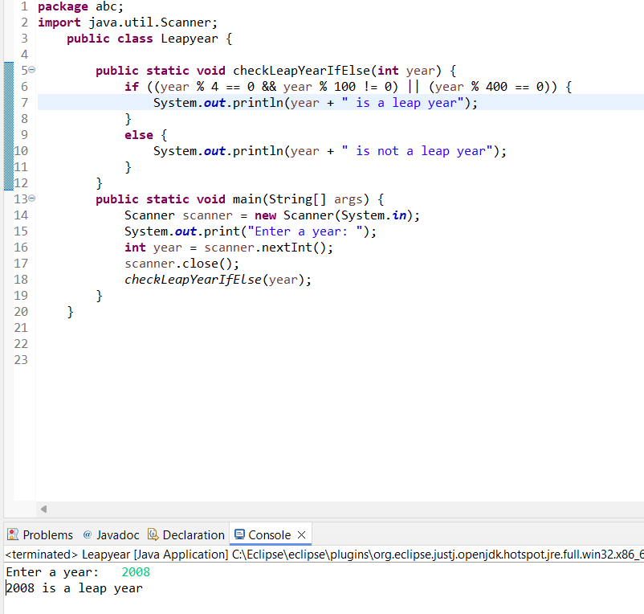

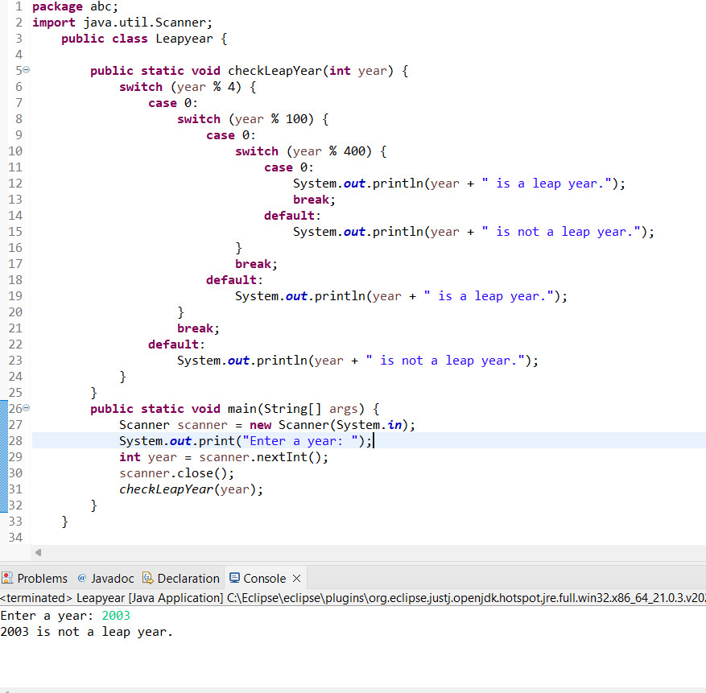

2)Implement a program that calculates the Body Mass Index (BMI) based on height and weight input using if-else to classify the BMI int categories (underweight, normal weight, overweight,etc).

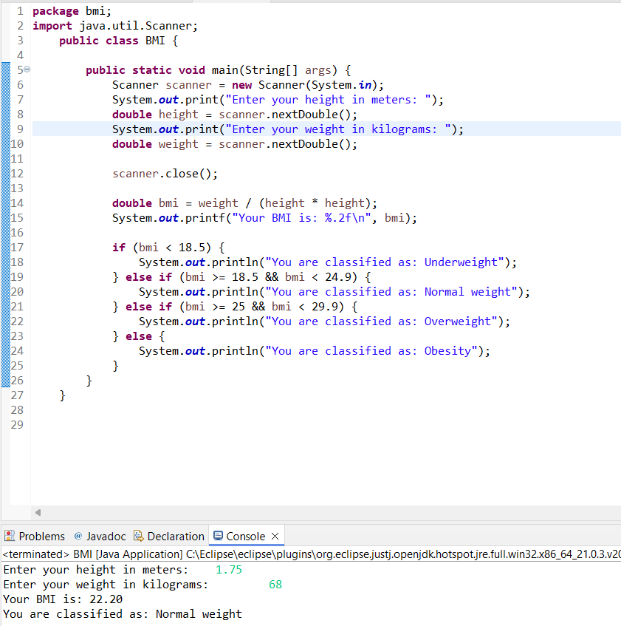

3)Write a program that checks if a person is eligible to vote based on their age.

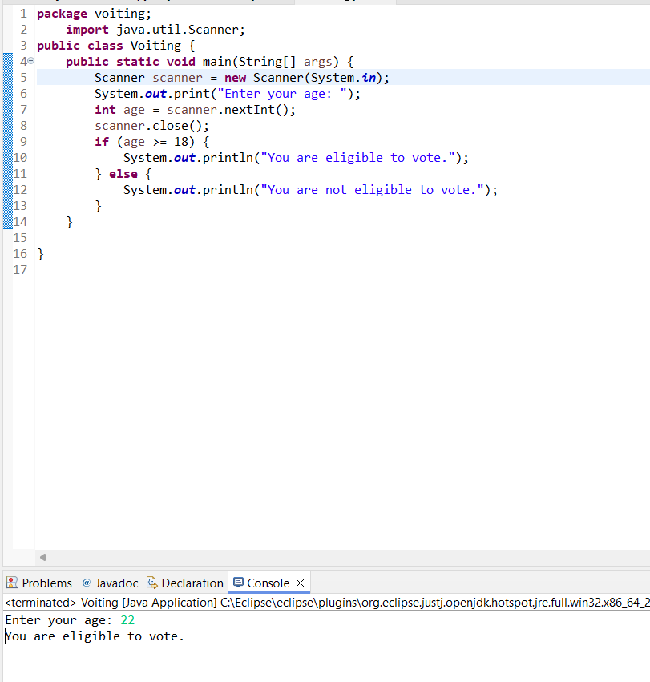

4)Write a program that takes a month (1-12) and prints the corresponding season (Winter, Spring, Summer, Autumn) using a switch case

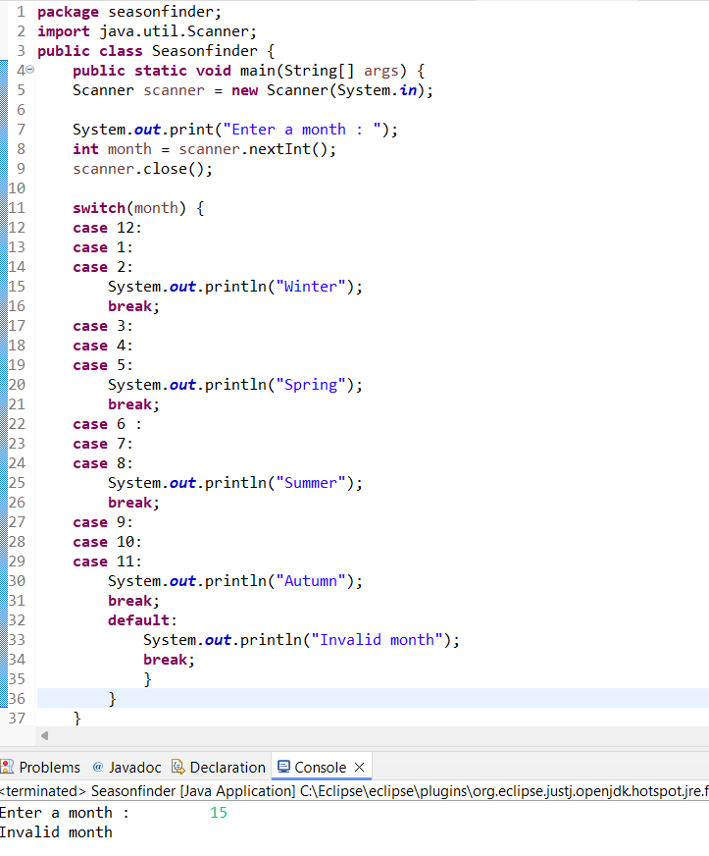

5)Write a program that allows the user to select a shape (Circle, Square, Rectangle, Triangle) and then calculates the area based on user-provided dimensions using a switch case.

**package** areacalculator;

**import** java.util.Scanner;

**public** **class** AreaCalculator {

**public** **static** **void** main(String[] args) {

Scanner scanner = **new** Scanner(System.***in***);

System.***out***.println("Select a shape to calculate the area:");

System.***out***.println("1. Circle");

System.***out***.println("2. Square");

System.***out***.println("3. Rectangle");

System.***out***.println("4. Triangle");

System.***out***.print("Enter your choice (1-4): ");

**int** choice = scanner.nextInt();

**double** area = 0;

**switch** (choice) {

**case** 1 : {

System.***out***.print("Enter the radius of the circle: ");

**double** radius = scanner.nextDouble();

area = Math.***PI*** * radius * radius;

System.***out***.printf("The area of the circle is: %.2f\n", area);

**break**;

}

**case** 2 : {

System.***out***.print("Enter the side length of the square: ");

**double** side = scanner.nextDouble();

area = side * side;

System.***out***.printf("The area of the square is: %.2f\n", area);

**break**;

}

**case** 3 : {

System.***out***.print("Enter the length of the rectangle: ");

**double** length = scanner.nextDouble();

System.***out***.print("Enter the width of the rectangle: ");

**double** width = scanner.nextDouble();

area = length * width;

System.***out***.printf("The area of the rectangle is: %.2f\n", area);

**break**;

}

**case** 4 : {

System.***out***.print("Enter the base of the triangle: ");

**double** base = scanner.nextDouble();

System.***out***.print("Enter the height of the triangle: ");

**double** height = scanner.nextDouble();

area = 0.5 * base * height;

System.***out***.printf("The area of the triangle is: %.2f\n", area);

**break**;

}

**default** : System.***out***.println("Invalid choice. ");

**break**;

}

scanner.close();

}

}